***E-Commerce Website Documentation***

**Introduction**

# An e-commerce website is an information technology method in which traders, businesses/distributors/marketers can sell products/services and the customer can purchase on that website electronically by using the internet on the mobile and computer. It means an e-commerce website is an online shop. E means electronic. Commerce means business. The website means the group of HTML web pages and that is created to market/sell information/products/services.

From a bigger perspective, every website on the internet is the e-commerce Website. It can be the platform, it can be a marketplace, it can be a portal, it can be apps, it can be an entertainment website, shopping website, online courses website, and online degree college.

**Design and Development**

# Frontend Web Developing:

* HTML
* CSS
* Bootstrap
* JavaScript

Backend Developing:

* php(WordPress)
* MySQL

**Features**

1. *Browser Compatibility:*

You can visit your website on any browsers like Google Chrome, Mozilla Firefox, Microsoft Explorer, Safari etc. Users typically view your website using a browser. Each browser interprets your website code in a slightly different manner, which means that it may appear differently to visitors using different browsers. In general, you should avoid relying on browser specific behavior, such as relying on a browser to correctly detect a content-type or encoding when you did not specify one.

1. *Fast Loading:*

* ******In short, your website should load as fast as possible!
* Ideal website load time for mobile sites is ***2-3 seconds***.
* A 3-second delay in load time resulted in abandonment rates of up to 81%.
* Google itself aims for under half-a-second load time.
* A very slow site can be a ***negative*** google ranking factor.
* Slow load times are a primary reason visitors abandon a checkout process.
* In studies, ***Page Time Load*** goes from 1s to 3s – the probability of bounce ***increases 32%.***
* In studies, Page Time Load goes from 1s to 5s – the probability of bounce ***increases 90%.***
* In a recent study, the average load time for a web page was 5.21s.
* Customer packaged goods sites take on average ***6.1 seconds*** to load.

1. *Search Engine Optimization:*

Our Websites are all ***SEO friendly*** and ***SEO*** ***optimized***. Search engines such as Google and Bing use bots to crawl pages on the web, going from site to site, collecting information about those pages and putting them in an index. Next, algorithms analyze pages in the index, taking into account hundreds of ranking factors or signals, to determine the order pages should appear in the search results for a given query.

1. *Contact form:*

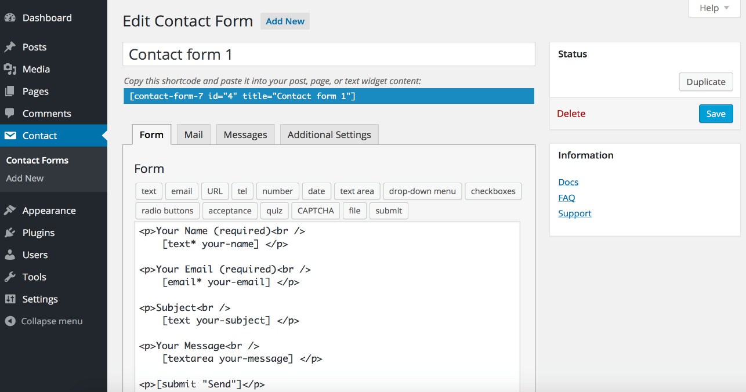

A page on a website that allows users to communicate with the site owner. The page has fields for filling in name, address and type of comment. On most company websites, email and mailing addresses are also included; however, the contact form provides an immediate, convenient way for users to ask the company questions.

Contact Form 7 can manage multiple contact forms, plus you can customize the form and the mail contents flexibly with simple markup. The form supports Ajax-powered submitting, CAPTCHA, filtering and so on.

1. *Google Map Integration:*

Maps Embed API maps are easy to add to your webpage—just set the URL you build as the value of an iframe's src attribute. Control the size of the map with the iframe's height and width attributes. No JavaScript required.

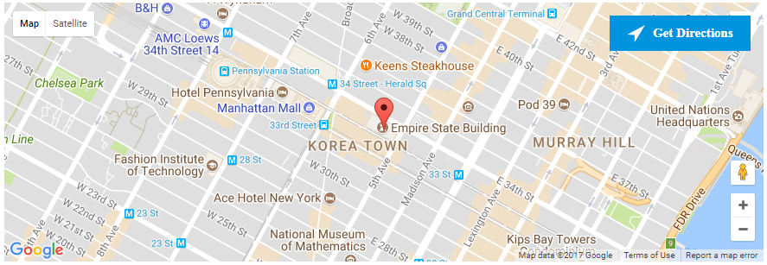This application is best for individuals and organizations looking to quickly determine factors such as market size, population density, catchment area statistics, and much more.

Harmness user-friendly mapping and visualization tools to determine the demographics of geographies anywhere on Earth. Data for small villages, city neighborhoods, and remote locations are now accessible to anyone.

1. *Livechat in Web Pages:*

Live Chat helps you greet your customers pro-actively while they are going through you website using the 'auto greetings' function and it also allows them to chat with you anonymously without providing their personal details like email or phone. This specifically helps during sales

1. *FAQ 24/7:*

No matter how clear and well-organized your website is, users with questions probably have to browse through a few pages looking for the right answer, which can be annoying for a visitor that just wants a quick answer to an easy question. By compiling answers to common questions on every possible topic related to your business, an FAQ page gives visitors a central place to find the answers they need.

**E-commerce Workflow:**

***UML Use Case Diagram***

Web Customer actor uses some web site to make purchases online. Top level use cases are View Items, Make Purchase and Client Register. View Items use case could be used by customer as top level use case if customer only wants to find and see some products. This use case could also be used as a part of Make Purchase use case. Client Register use case allows customer to register on the web site, for example to get some coupons or be invited to private sales. Note, that Checkout use case is include use case not available by itself - checkout is part of making purchase.

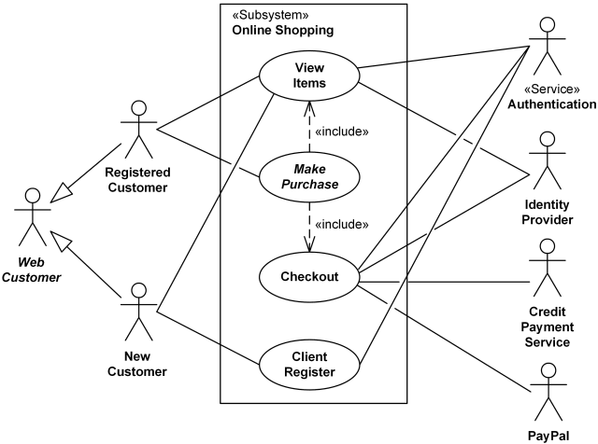

***Online shopping UML use case diagram example - top level use cases.***

View Items use case is extended by several optional use cases - customer may search for items, browse catalog, view items recommended for him/her, add items to shopping cart or wish list. All these use cases are extending use cases because they provide some optional functions allowing customer to find item.

Customer Authentication use case is included in View Recommended Items and Add to Wish List because both require the customer to be authenticated. At the same time, item could be added to the shopping cart without user authentication.

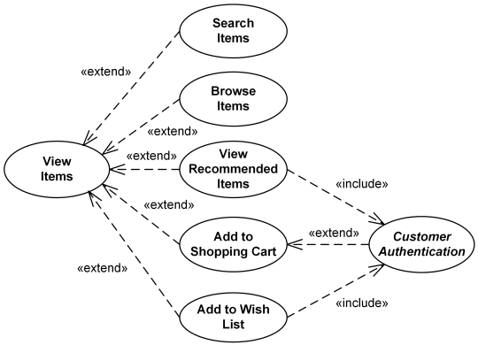

***Online shopping UML use case diagram example -view items use case.***

Checkout use case includes several required uses cases. Web customer should be authenticated. It could be done through user login page, user authentication cookie ("Remember me") or Single Sign-On (SSO). Web site authentication service is used in all these use cases, while SSO also requires participation of external identity provider.

Checkout use case also includes Payment use case which could be done either by using credit card and external credit payment service or with PayPal.

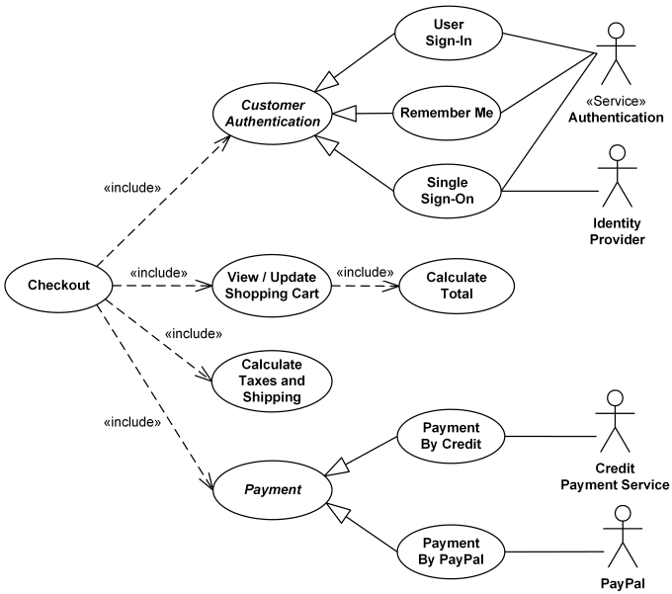

***Online shopping UML use case diagram example - checkout, authentication and payment use cases.***

**E-commerce**

**Payment Processing:**

***UML Use Case Diagram***

This UML use case diagram example shows some use cases for a system which processes credit cards.

Credit Card Processing System (aka Credit Card Payment Gateway) is a subject, i.e. system under design or consideration. Primary actor for the system is a Merchant’s Credit Card Processing System. If transaction is approved, funds will be transferred to merchant's bank account.

Authorize and Capture use case is the most common type of credit card transaction. The requested amount of money should be first authorized by Customer's Credit Card Bank, and if approved, is further submitted for settlement. During the settlement funds approved for the credit card transaction are deposited into the Merchant's Bank account.

In some cases, only authorization is requested and the transaction will not be sent for settlement. In this case, usually if no further action is taken within some number of days, the authorization expires. Merchants can submit this request if they want to verify the availability of funds on the customer’s credit card, if item is not currently in stock, or if merchant wants to review orders before shipping.Previously authorized transaction - either submitted through the payment gateway or requested without using the system, e.g. using voice authorization.

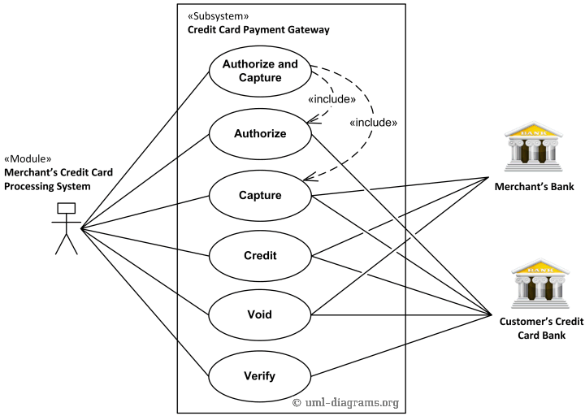

***UML use case diagram example for a credit cards processing system.***

Credit use case describes situations when customer should receive a refund for a transaction that was either successfully processed or settled through the system or for some transaction that was not originally submitted through the payment gateway.

.

You can find excellent resources, documentation, white papers, guides, etc. related to the credit card processing at Authorize WordPress payment getaway accept online payment.

**Conclusion:**

The internet has become a major resource in modern business, thus electronic shopping has gained significance not only from the entrepreneur’s but also from the customer’s point of view. For the entrepreneur, electronic shopping generates new business opportunities and for the customer, it makes comparative shopping possible.

In this website, we use woo-commerce plugin which is functionally made by PHP. By using this plugin we can add any product to the cart. Then you can check out the product. And by the process, you can get a payment getaway method system.